Hong Kong Institute of Vocational Education
Department of Information and Communications Technology
ITP4501– Programming Techniques for Mobile Systems
Lab 01 – Introduction to Android

Exercise 1 – Your first Android application

- Refer to the section “Your 1St Android Application” in the chapter 1 (Introduction to Android) of the lecture notes.
- Create and build an Android application with the following project settings:
On the new Project screen
Application Name | My First Android Program
Company Domain | android.exercise.com (or use default value)
Project location | .../…/MyFirstAndroidProgram (or use default value)
On the selected platforms screen
Platform | Phone and Tablet
Language | Java
Minimum SDK | API 26 (“Oreo”; Android 8.0)
On the Add Activity screen, select “Empty Views Activity” (for Android Studio Jelly Fish or later, or use default value)
On the Customize the Activity screen
Activity Name | HelloAndroidActivity (or use default value)  select Generate Layout File
Layout Name | activity_hello_android (or use default value)  select Backwards Compatibility (AppCompat)

- Run your application. The Android platform emulator will be launched automatically. However, be patient while it is being launched and initialized.
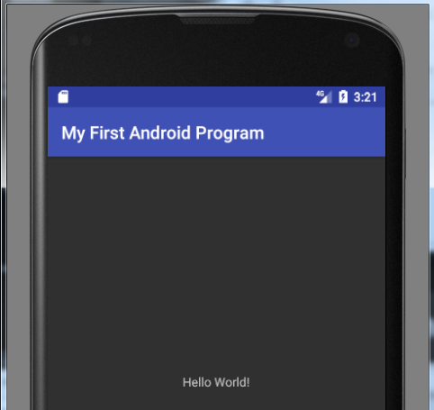

- Get yourself familiar with the project structure. Pay special attention to
  - java (the package and Java source file),
  - res layout activity_hello_android.xml, and
  - res values strings.xml

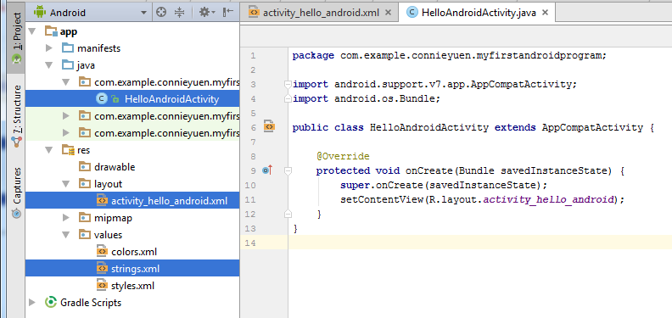
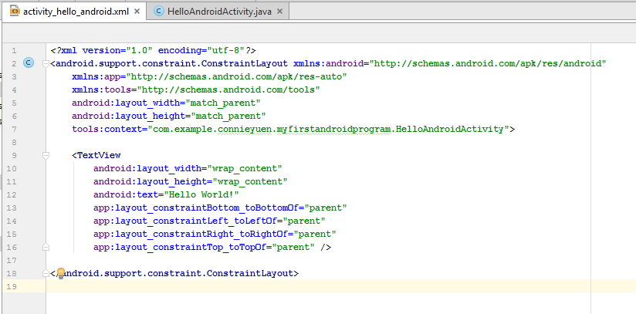

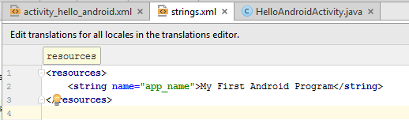

- Modify the Android application you produced in Exercise 1 so that the appearance of the application becomes:
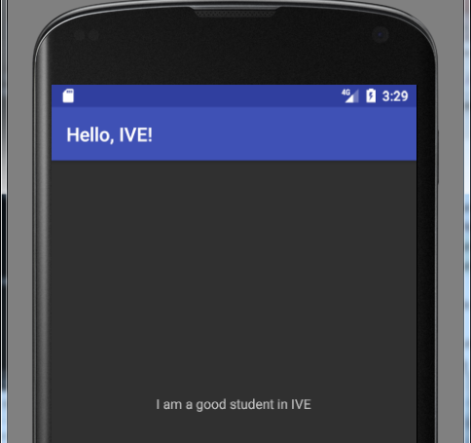

Exercise 2 – Activity Lifecycle

- Import the Android application “LifeCycle1”.
- Observe the callback method implemented as indicated by the toast message and complete Table1 for the following steps:
  - Compile and run the application (Figure 1).
  - Input some data to the Text Box and click the “Dialog” button (Figure 2).

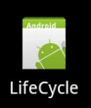
  - Then click the “Close button” of the Dialog.

  - Press the emulator’s HOME button.

  - From the launch pad, select the icon of the “LifeCycle” application and launch the application again.
  - Click the “Finish” button.

Table1
Step | Callback methods implemented | State | Input data saved?
1. | onCreate(), onStart(), onResume()
2.
3. |  |  | Y / N
4.
5. |  |  | Y / N
6.

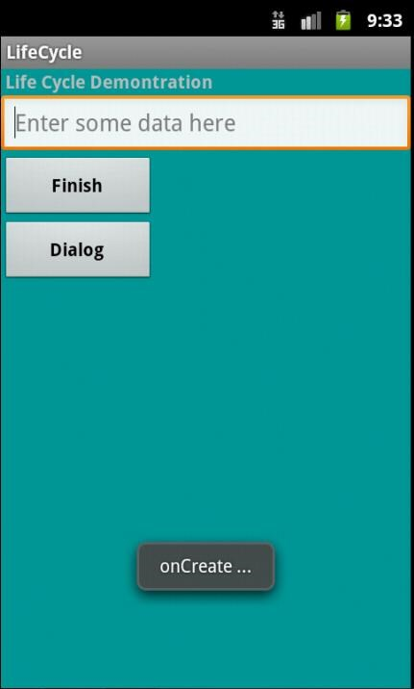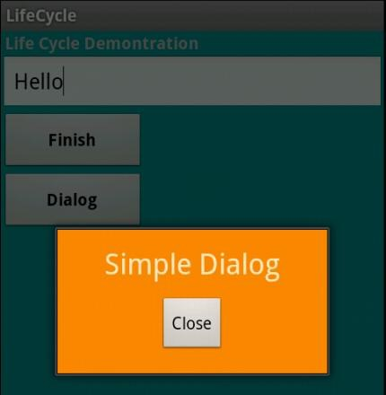

Toast Message

Dialog

Figure 1 Figure 2

- Figure 3 shows a simplified illustration of the Activity lifecycle, expressed as a step pyramid. This shows how, for every callback used to take the activity a step toward the Resumed state at the top, there's a callback method that takes the activity a step down.
The activity can also return to the resumed state from the Paused and Stopped state.
➢ Fill in the missing methods in the rectangles of Figure 3.

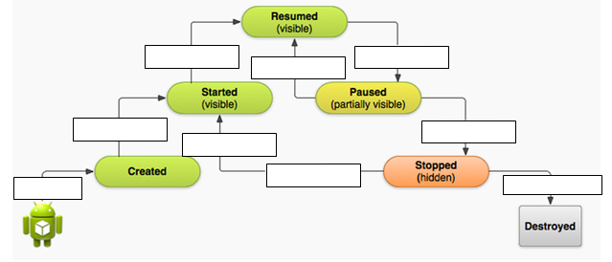
Figure 3

End.

